# INTRODUCTION

### Need of the project:

The **need for the Online Auction System** arises from the increasing demand for a digital platform that facilitates transparent and efficient bidding. It provides a convenient way for buyers and sellers to engage in auctions anytime, anywhere. The system ensures fair competition, secure transactions, and automated bidding processes. It eliminates geographical limitations and reduces the operational costs of traditional auctions. Additionally, it enhances user experience with features like real-time bidding, chat support, and automated notifications.

### Survey of the project:

Here are excerpts from authenticated references on online auction systems, presented with the authors' names, publication year, and relevant information:

**Prashant Kaushik, Aditya Kumar Singh, Ajay Kumar, Ms. Nikita Verma, Mr. Arun Kumar Rai (2024):** "*An online auction is a type of auction that takes place over the Internet*. It is a popular method for buying and selling products and services. Such systems give the best price to the seller as well as the buyers."[1]

**Peters and Severinov** (2006) prove that “when there are many sellers and buyers in online- auction markets*, the reserve prices set by the sellers are equal to their marginal costs. In contrast to sealed-bid auctions with simultaneous choice of reserve prices, it is unlikely that in online markets sellers choose reserve prices simultaneously”.* Rather, a seller who comes to the market first, chooses a reserve price expecting a subsequent arrival of another seller. Such a strategic environment may be framed as a Stackelberg-like model where sellers choose reserve prices, and our results are consistent with the standard symmetric Stackelberg model, in which the first-moving seller earns a higher profit[2]

**Sumeet Shelar, Shivam Sharma, Sagar Sharma, Pallavi Chandratre (2022):** "*E-Auction System is an effective E-Commerce system that allows bidders and sellers to interact through an online platform*. This online mode has reduced many limitations of traditional auctions, i.e., geographical location, timing and traveling, a limited number of people, etc." [3]

**Prathamesh Borole, Yoges Dhawale, Pranav Kaple, Utkarsh Gadhave, Asst. Prof. Amol Take (2024):** "The Advanced Online Auction System Using Python, Cloud Computing, and Blockchain Integration' is a pioneering project designed to transform the landscape of online auctions. This project leverages the synergistic power of Python programming, cloud

computing infrastructure, and Blockchain technology to create an innovative online auction platform." [4]

**Raghda T. Elias, Auday H. AL-Wattar (2022):** "Online auction sites are a great way for people to buy and sell goods without the hassle of haggling prices or advertising items. *It's also a good place for small businesses to advertise their products because they can attract more buyers with even small advertising budgets.*[5]

**Hongyan Yu, Srikanta Patnaik, Shenjia Ji, Liguo Jia, Tengxiao Yang (2017):** "With the rapid growth of E-commerce, online auction has become an active business model. *Online auctions represent a special class of negotiations with many applications in conducting e- business transactions."* [6]

**Yun Shu (2018):** "*In recent decades, Internet auctions have already grown up as the most significant e-commerce business model worldwide*. Meanwhile, with the rapid rise of cloud computing over the past few years, the legacy online auction platform is gradually replaced by service-oriented cloud computing in real time." [7]

**Bajari and Hortacsu** (2004) A handful of papers in the literature consider the case in which sellers compete against each other (see for instance McAfee, 1993; Peters and Severinov, 1997).1 These papers assume that bidders can only choose to buy from one seller, and the only equilibrium involves bidders randomizing over available sellers. In this case, it is entirely possible that some auctions should have many bidders while other auctions have few or no bidders, and consequently that some profitable trades may not be realized*. Several recent papers provide empirical analyses of the online auction market, surveyed by Bajari and Hortacsu (2004) in their comprehensive review of the empirical literature.*It is worth noting that all the papers in this rapidly growing empirical literature treat online auctions as independent of one another*.*[8]

**Prashant Kaushik, Aditya Kumar Singh, Ajay Kumar, Ms. Nikita Verma, Mr. Arun Kumar Rai (2024):** "An online auction system permits a customer to submit online orders for items and/or services from a store that serves both walk-in customers and online customers."[9]

#### Explaining and Forecasting Online Auction Prices and Their Dynamics Using Functional Data Analysis

**Shanshan Wang ,Wolfgang Jank ,Galit Shmueli** Published online: (01 Jan 2012):

*Forecasting price in online auctions is challenging because traditional forecasting methods cannot adequately account for two features of online auction data: (1) the unequal spacing of bids and (2) the changing dynamics of price and bidding throughout the auction.* Our dynamic forecasting model accounts for these special features by using modern functional data analysis techniques. Specifically, we estimate an auction's price velocity and acceleration and use these dynamics, together with other auction-related information, to develop a dynamic functional

forecasting model. We also use the functional context to systematically describe the empirical regularities of auction dynamics. We apply our method to a novel set of Harry Potter and Microsoft Xbox data and show that our forecasting model outperforms traditional methods.[10]

### About the project:

The Online Auction System is a web-based application that facilitates the process of auctioning products in a digital marketplace. Unlike traditional physical auctions, this system enables buyers and sellers to participate in bidding activities from any location with internet access. It provides a dynamic and competitive platform where users can bid for products, ensuring transparency and efficiency in the auctioning process.

The system is developed using PHP for backend processing, MySQL for database management, and HTML, CSS, JavaScript, AJAX and Bootstrap for an interactive frontend. The auction process involves sellers listing products with starting bids, bidders placing competitive offers, and the highest bidder winning the auction at the end of the specified time.

This presents a comprehensive analysis of the system, including software requirements, system architecture, database design, functional modules, testing, and future enhancements. The project aims to create a secure and user-friendly auctioning platform with key features such as user authentication, bidding mechanisms, product management, payment processing, and real- time notifications.

Additionally, this report discusses security measures, challenges faced during development, and potential improvements that can be integrated in future versions. By leveraging modern web technologies, the Online Auction System ensures a seamless experience for users while promoting fair and efficient online auctions.

# SYSTEM STUDY & ANALYSIS

## SYSTEM REQUIREMENTS

#### HARDWARE REQUIREMENTS:

* + - Processor - Intel Pentium IV
    - Processor Speed – 1.40 GHz
    - RAM – 2 GB or above.
    - Monitor resolution - A color monitor with minimum resolution of 1000*700

#### SOFTWARE REQUIREMENTS

* + - IDE: AdobeDreamweaverCS6.0
    - Front-end: PHP 5.2
    - Back-end: MySQL Server 5.1.1

#### LANGUAGES TO BE USED

* + - FRONT END: HTML, CSS, BOOTSTRAP
    - BACK END: PHP, MYSQL

## EXISTING SYSTEM & PROPOSED SYSTEM

#### Existing System:

The traditional auction system operates in either physical auction houses or through basic online auction platforms with limited functionalities. These systems have several drawbacks, including:

* + - Limited Accessibility: Traditional auctions require physical presence, making participation difficult for remote users.
    - Manual Bidding Process: Some online platforms lack real-time automated bidding, making the process slow and inefficient.
    - Security Concerns: Existing systems may lack strong security features, making them vulnerable to fraud and unauthorized access.
    - Poor User Experience: Many outdated online auction systems have non-responsive interfaces, making them difficult to use on mobile devices.
    - Lack of Automation: Traditional systems do not provide real-time updates, notifications, or automated bid tracking.

#### Proposed system:

To overcome the limitations of the existing system, the Online Auction System is designed with modern web technologies to enhance efficiency, security, and user experience.

#### Key Features of the Proposed System:

* + - Web-Based Platform: Users can access the auction system from anywhere using a web browser. No need for physical presence, making it convenient and accessible.
    - User Authentication & Security: Secure login and registration process to prevent unauthorized access. Password encryption and SQL injection prevention ensure data safety.
    - Automated Bidding System: Users can place bids in real time, and the highest bid is automatically updated without page refresh. Real-time notifications inform bidders about their bid status.
    - Advanced Product Listing & Search: Sellers can list products with images, descriptions, and bidding details. Buyers can search for specific products using category filters.
    - Responsive & User-Friendly Design: Built with Bootstrap, ensuring the system works seamlessly on mobile, tablet, and desktop devices.
    - Integrated Chat & Support System: Buyers can directly message sellers for queries. 24/7 chat feature ensures smooth communication.
    - Future Expandability: The system is designed to support multi-currency transactions, mobile app integration, and GPS-based tracking in future updates.

The proposed Online Auction System improves upon the limitations of the existing system by integrating modern technology, real-time functionalities, enhanced security, and a user-friendly experience. This system ensures fair, efficient, and accessible online auctions for both sellers and buyers.

## TECHNOLOGIES USED

The Online Auction System is built using a combination of web technologies to ensure a robust, scalable, and efficient platform. The system primarily relies on PHP and MySQL for backend operations, while the frontend is developed using modern web technologies to enhance user experience. Below is a breakdown of the key technologies used in the project:

#### Backend Technologies

* + PHP 5.2: A server-side scripting language used for handling user authentication, processing bids, managing auctions, and performing database interactions. Ensures dynamic content generation and secure transactions.
  + MySQL Server 5.1.1: A relational database management system used for storing and retrieving data related to users, products, bids, and transactions. Ensures efficient data handling with structured queries.

#### Frontend Technologies

* + HTML (Hyper Text Markup Language): Defines the structure of the web pages and forms the foundation of the auction interface.
  + CSS (Cascading Style Sheets): Enhances the visual presentation of the website by providing styling and layout customization.
  + JavaScript: Provides interactive elements such as bid updates, countdown timers, and user validation.
  + AJAX (Asynchronous JavaScript and XML): Enables real-time bid updates without reloading the page, ensuring smooth user experience.
  + Bootstrap: A responsive front-end framework used to design a user-friendly and mobile- compatible interface.

#### Development Tools & IDEs

* + Adobe Dreamweaver CS6.0: A web development IDE used for designing, coding, and managing the auction system’s frontend and backend.
  + Notepad: A lightweight text editor used for code development and debugging.

#### Server & Hosting

* + Apache Server: A widely used open-source web server that hosts the PHP-based application and processes client requests.

#### Security Measures

* + Session Management & Authentication: Ensures that only registered users can participate in auctions and prevents unauthorized access.
  + Data Encryption: Passwords and sensitive user information are encrypted for security.

These technologies work together to deliver a secure, scalable, and high-performing online auction system, providing an efficient auctioning experience for users.

## MODULES OF THE PROJECT

**Login/registration module:** Those who wish to take part in Bidding or sell products at the site have to register at the site as customer. Only authenticated users can take part in selling or in bidding. In this module customer can register to the system by entering registration details. After the registration they can login to the system by entering unique login id and password.

* + - **CUSTOMER MODULE:** In the customer module customer can view his own bidding details, Purchase report, auction winning report, etc.
    - **PRODUCT LIST MODULE:** This collects information like product name, product detail, product image, Start bid, Sale price, Bidding start date and end date.
    - **CATEGORY MODULE**: Before uploading product Customer should select category details. In the website product displays under the category list.
    - **BIDDING MODULE**: In the bidding module customer can bid for products Customer can select any item and they can bid for the product.
    - **PURCHASE MODULE:** This module is for winning bids where customer can pay for winning bids. After the payment seller needs to deliver the product to customer.
    - **REPORT MODULE**: This module is for administrator to check sales report, product report, auction report, payment report, etc.
    - **DASHBOARD MODULE:** This dashboard module is for administrator and employees. Admin has full authority of the website and employee has limited authority.
    - **SETTINGS MODULE:** Here administrator can add employees, categories, website settings, etc.

# SYSTEM DESIGN

System Design is a solution a “How to “approach to the creation of a new system. The importance phase is composed of several steps. It provides the understanding of procedural detail necessary for the system recommended in the feasibility study. Emphasis is on translating the performance requirement into design specification.

### User Flow Sequence Diagram:

#### Seller Flow Sequence Diagram

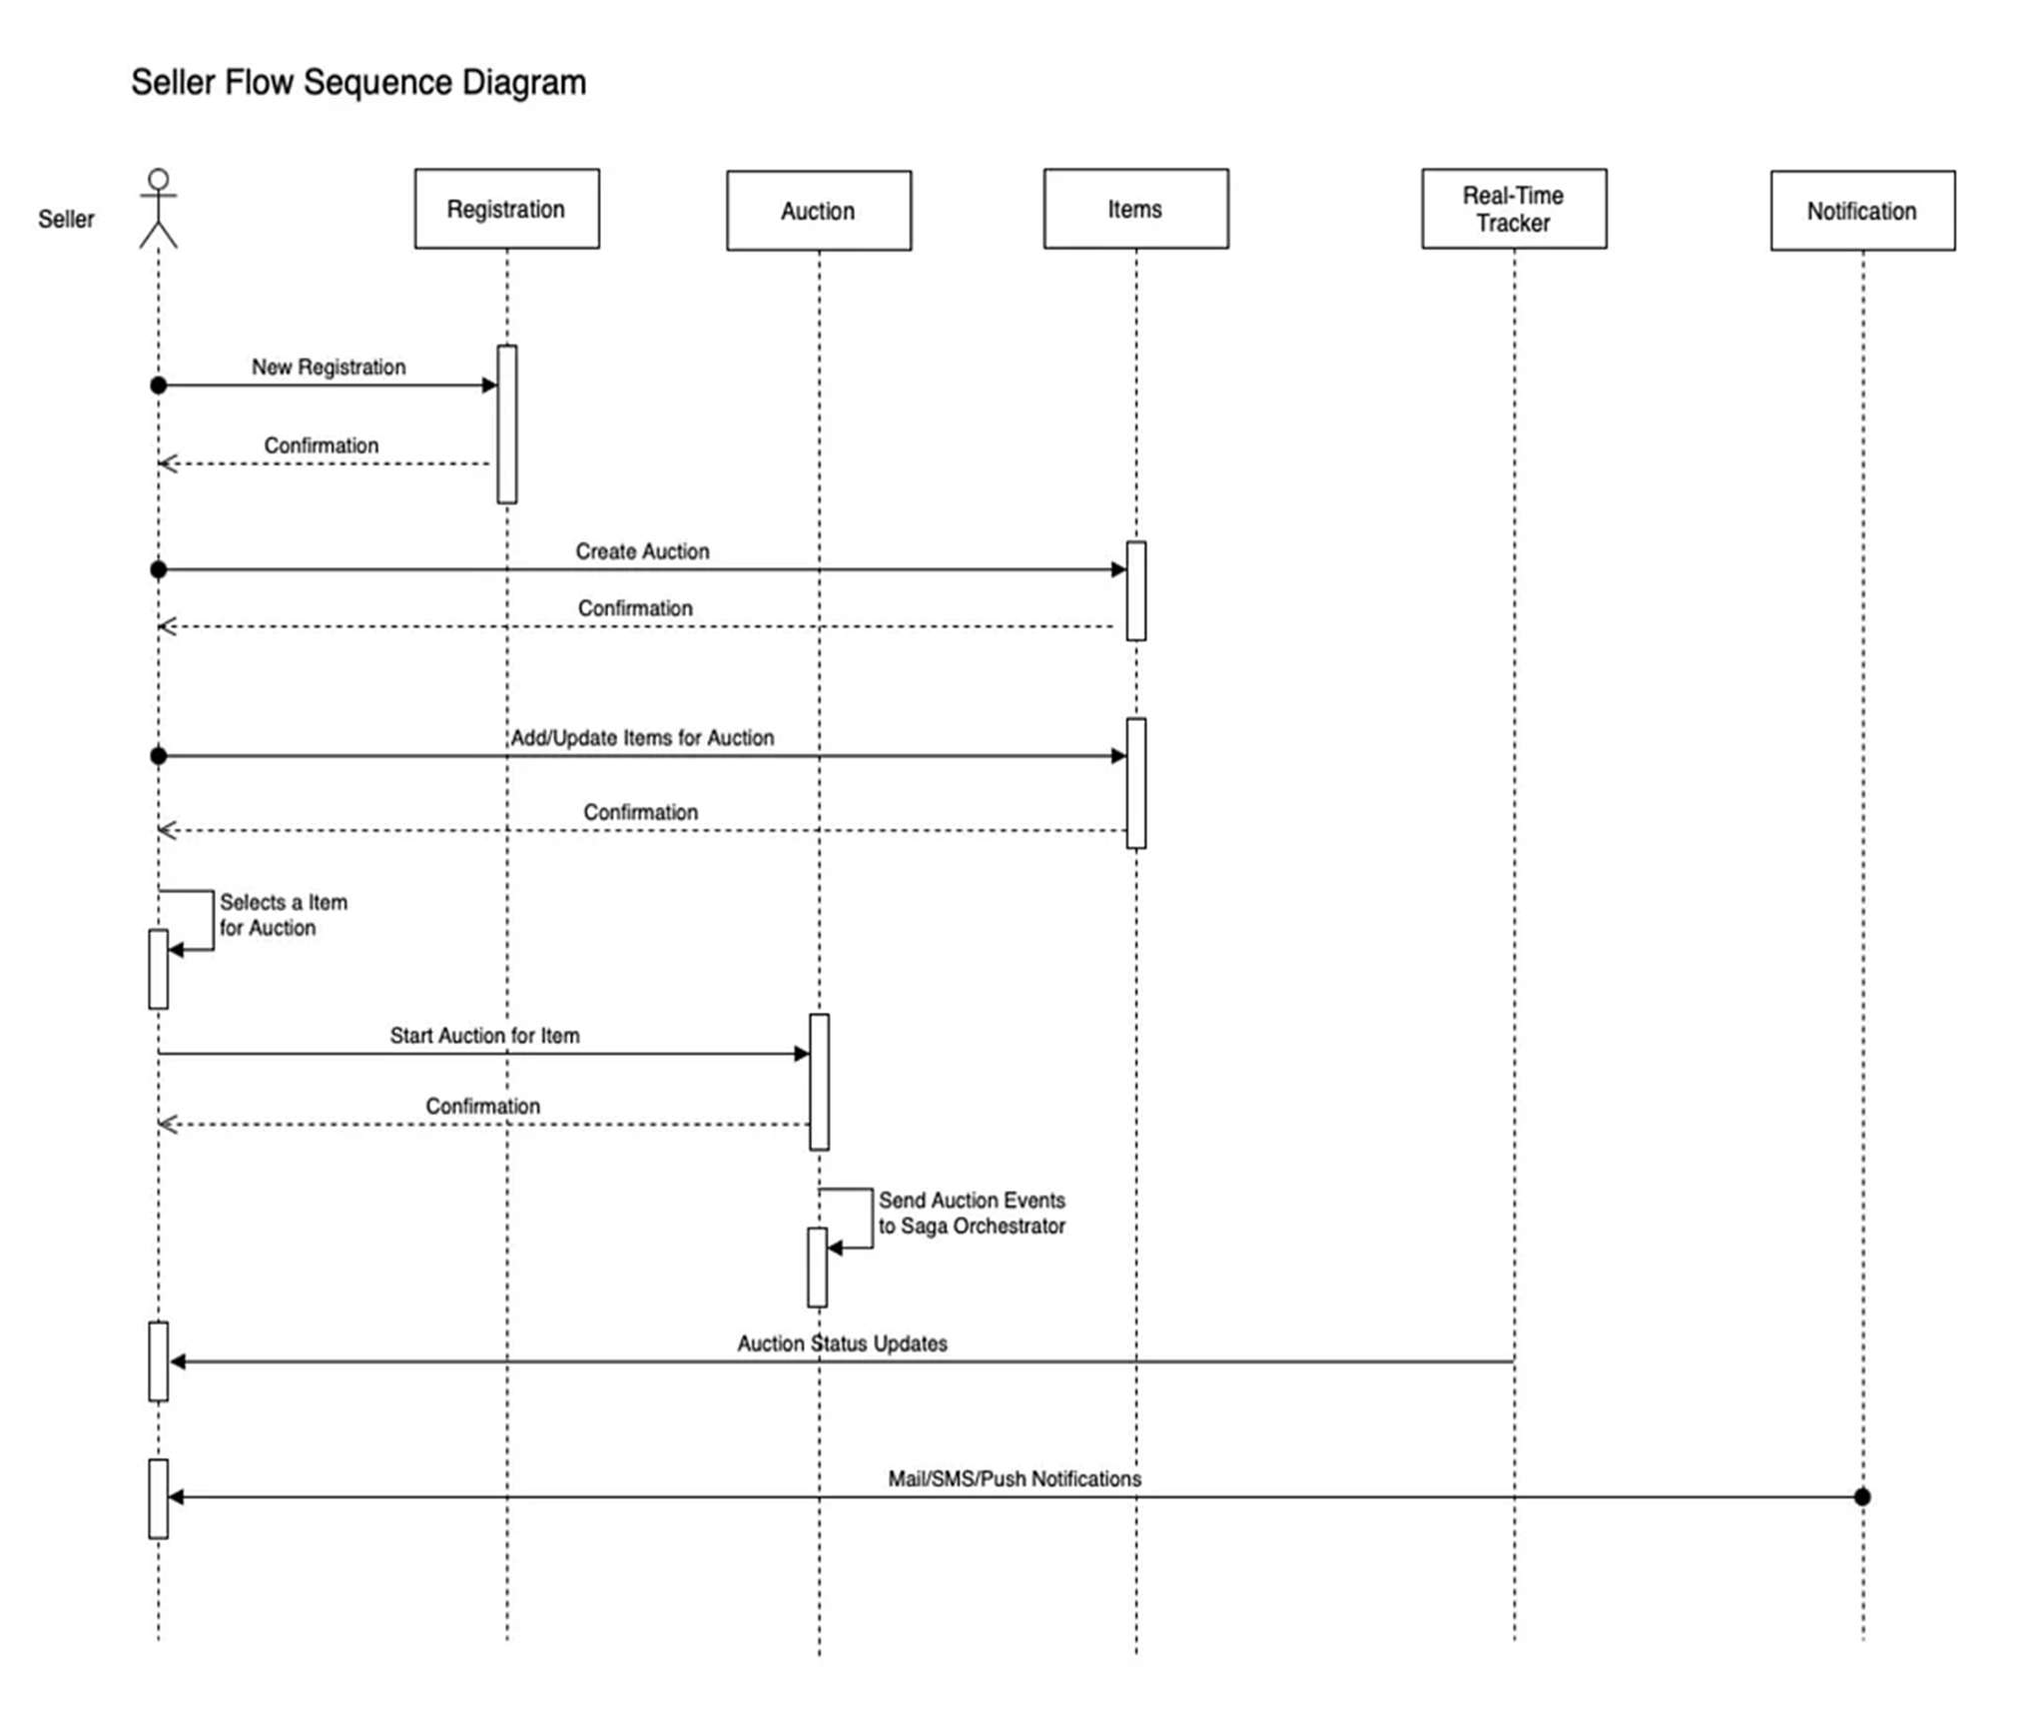

The sequence diagram shows the seller's journey in an auction system. It includes registration, auction creation, item management, and starting an auction. Auction events are sent for tracking, and notifications are sent to update the seller.

#### Bidder Flow Sequence Diagram

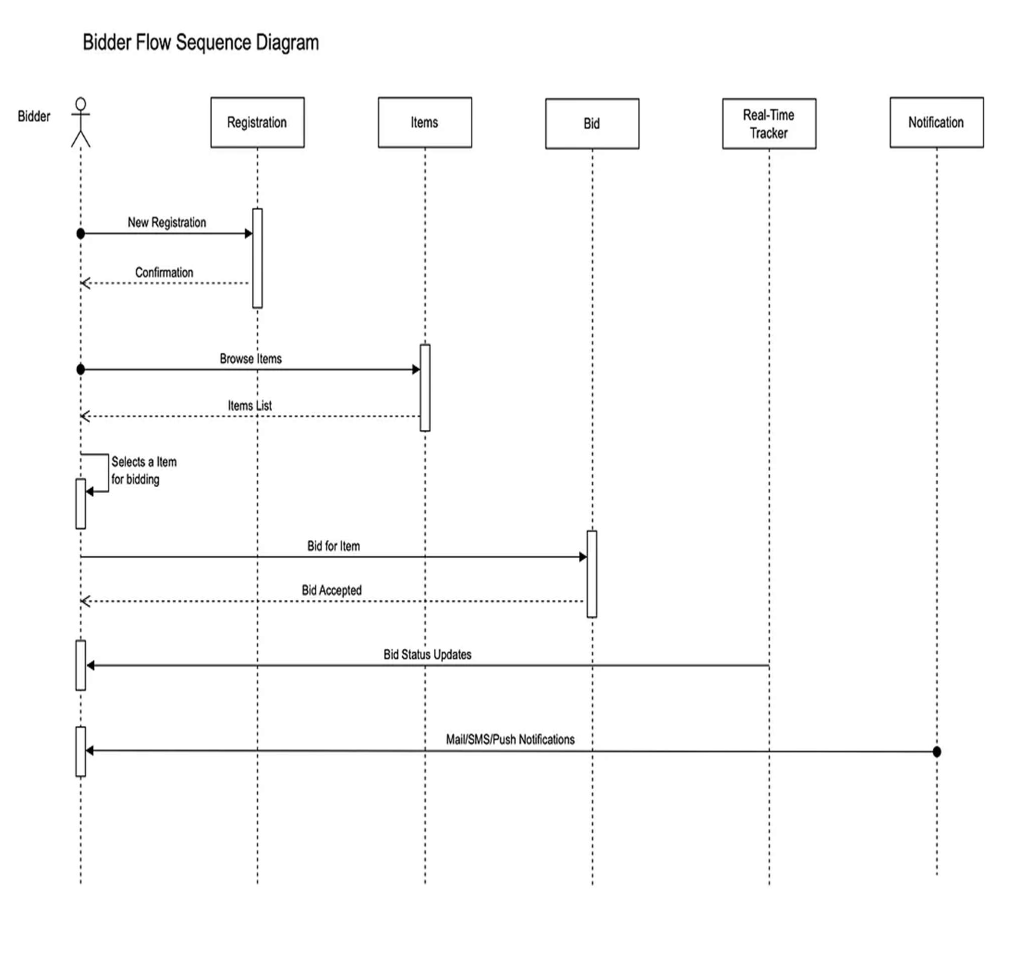

The sequence diagram depicts a bidder's interaction in an auction system. The bidder first registers, then browses items, selects one to bid on, and submits a bid. The system then provides real-time bid status updates and sends notifications to the bidder.

### ER Diagrams:



This is an Entity-Relationship Diagram (ERD) representing an online auction system. Here’s a short explanation of the key entities and their relationships:

#### Admin & Employee:

* The admin manages employees, who have credentials (employee_id, login_id, password, etc.).
* Employees add product categories.

#### Customers:

* Customers have attributes like customer_id, name, email_id, and password.
* Customers can upload products for auction.

#### Products & Categories:

* Products belong to categories (category_id, category_name).
* A product has details like product_id, name, and starting_bid.

#### Bidding Process:

* Customers perform bids on products.
* Bidding has attributes like bidding_id, amount, date_time, and status.

#### Messages & Notifications:

* Customers can send messages (message_id, message_date_time, status).

#### Auction Winners:

The system determines winners based on the highest bid (winner_id, winning_bid).

#### Billing & Payment:

* Winners proceed to billing (billing_id, purchase_date, purchase_amount).
* Payments are made via different payment types (payment_id, paid_amount, status, payment_type, card_type).

This ERD outlines the relationships between users, products, bids, and transactions in an auction system.

# IMPLEMENTATION

The Online Auction System is implemented as a web application using PHP, MySQL, HTML, CSS, JavaScript, AJAX, and Bootstrap. The system allows users to register, list products, place bids, process payments, and generate reports. The backend uses MySQL for data storage and PHP for server-side processing. The frontend ensures a responsive and user-friendly experience.

## ALGORITHMS

The system uses several key algorithms:

#### User Authentication Algorithm (Login & Registration):

* + - Checks if the entered username and password match stored credentials.
    - Uses password encryption for security.
    - Prevents unauthorized access.

#### Bidding Algorithm:

* + - Retrieves the highest bid from the database.
    - Compares the new bid with the highest bid.
    - Updates the highest bid if the new bid is greater.

#### Auction Winner Selection Algorithm:

* + - At auction end, the system checks the highest bid.
    - Declares the highest bidder as the winner.
    - Sends a notification to the winner and seller.

#### Payment Processing Algorithm:

* + - Validates the transaction details.
    - Ensures the highest bidder completes the payment.
    - Confirms order completion after successful payment.

## FUNCTIONAL MODULES

**Login/Registration module:** Those who wish to take part in bidding or sell products at the site have to register at the site as customer. Only authenticated users can take part in selling or in bidding. In this module customer can register to the system by entering registration details. After the registration they can login to the system by entering unique login id and password.

This module has following sub modules:

* + - Login module
    - Registration module

**Customer account module:** In the customer account module customer can view his own bidding details, Purchase report, auction winning report, etc. Even the customer can change his password and he can update the password in the account section.

This module has following sub modules:

* + - Customer account
    - Customer profile
    - Change password
    - Update profile
    - View bidding details
    - View auction records

**Product list module:** This module allows sellers to add auction products. This collects information like product name, product category, product detail, product image, Start bid, Sale price, Bidding start date and end date from seller.

This module has following sub modules:

* + - Add produc
    - Product list module
    - Update product

**Category module**: Before uploading product, Customer should select category details. In the website product displays under the category list. Only administrator can add category records.

This module has following sub modules:

* + - Add category
    - View category

**Search module:** In this module customer can search for particular products. After searching the system display records in the search list.

This module has following sub modules:

* + - Search product list
    - View product list

**Bidding Module:** In the bidding module customer can bid for products. Customer can select any item and they can bid for the product.

This module has following sub modules:

* + - Product Bidding module
    - View bidders
    - View bidding records

**Purchase module:** This module is for winning bids where customer can pay for winning bids. After the payment seller needs to deliver the product to customer.

This module has following sub modules:

* + - Purchase product
    - View purchase detail

**Chat module:** If the customer has any queries regarding product they can directly contact with sellers. 24x7 online chat features available. If the seller is offline then the message stores under seller message box.

This module has following sub modules:

* + - Compose message
    - View sent messages
    - View Received messages

**Report module:** This module is for administrator to check sales report, product report, auction report, payment report, etc.

This has following sub modules

* + - View customers
    - View messages
    - View bidding items
    - View winners list

**Dashboard module:** This dashboard module is for administrator and employees. Admin has full authority of the website and employee has limited authority.

This module has following sub modules:

* + - View dashboard
    - View profile
    - Update profile
    - Change password

**Settings module:** Here administrator can add employees, categories, website settings, etc.

* + - Add employees
    - View employees
    - Add category
    - View category

## SAMPLE CODING:

#### Registration Form (HTML + JavaScript Validation)

<!DOCTYPE html>

<html lang="en">

<head>

<title>Register</title>

<script>

function validateForm() {

let name = document.getElementById("name").value.trim(); let email = document.getElementById("email").value.trim(); let mobile = document.getElementById("mobile").value.trim();

let password = document.getElementById("password").value.trim(); let cpassword = document.getElementById("cpassword").value.trim(); let emailPattern = /^[\w\.-]+@[a-zA-Z0-9\.-]+\.[a-zA-Z]{2,}$/;

let passwordPattern = /^(?=.*\d)(?=.*[a-z])(?=.*[A-Z]).{8,16}$/; if (name.length < 3 || name.length > 15) {

alert("Name must be between 3 and 15 characters."); return false;

}

if (!email.match(emailPattern)) { alert("Invalid email format."); return false;

}

if (!mobile.startsWith("+91") || mobile.length !== 13) { alert("Mobile number must be 10 digits and start with +91."); return false;

}

if (!password.match(passwordPattern)) {

alert("Password must be 8-16 characters with uppercase, lowercase, and a digit."); return false;

}

if (password !== cpassword) { alert("Passwords do not match."); return false;

}

return true;

}

</script>

</head>

<body>

<h2>Register</h2>

<form action="register.php" method="POST" onsubmit="return validateForm()">

<label>Name:</label>

<input type="text" id="name" name="name" required><br><br>

<label>Email:</label>

<input type="email" id="email" name="email" required><br><br>

<label>Mobile No:</label>

<input type="text" id="mobile" name="mobile" value="+91" required><br><br>

<label>Password:</label>

<input type="password" id="password" name="password" required><br><br>

<label>Confirm Password:</label>

<input type="password" id="cpassword" name="cpassword" required><br><br>

<button type="submit">Register</button>

</form>

</body>

</html>

#### PHP Backend (register.php)

<?php

include("config.php"); // Database connection

if ($_SERVER["REQUEST_METHOD"] == "POST") {

$name = mysqli_real_escape_string($conn, trim($_POST['name']));

$email = mysqli_real_escape_string($conn, trim($_POST['email']));

$mobile = mysqli_real_escape_string($conn, trim($_POST['mobile']));

$password = password_hash($_POST['password'], PASSWORD_BCRYPT);

$sql = "INSERT INTO users (name, email, mobile, password) VALUES ('$name', '$email', '$mobile', '$password')";

if (mysqli_query($conn, $sql)) {

echo "<script>alert('Registration Successful!'); window.location='login.php';</script>";

} else {

echo "<script>alert('Error: " . mysqli_error($conn) . "');</script>";

}

}

?>

#### Bidding Timer:

<?php session_start();

$highestBid = isset($_SESSION['highestBid']) ? $_SESSION['highestBid'] : 0;

$highestBidder = isset($_SESSION['highestBidder']) ? $_SESSION['highestBidder'] : "No bids yet";

$auctionTime = isset($_SESSION['auctionTime']) ? $_SESSION['auctionTime'] : 60; if ($_SERVER['REQUEST_METHOD'] == 'POST' && isset($_POST['bid'])) {

$bidderName = $_POST['bidderName'];

$bidAmount = floatval($_POST['bidAmount']); if ($bidAmount > $highestBid) {

$_SESSION['highestBid'] = $bidAmount;

$_SESSION['highestBidder'] = $bidderName;

$highestBid = $bidAmount;

$highestBidder = $bidderName;

} else {

echo "<script>alert('Bid must be higher than the current highest bid!');</script>";

}

}

if (!isset($_SESSION['timerStarted'])) {

$_SESSION['timerStarted'] = time();

}

$timeElapsed = time() - $_SESSION['timerStarted'];

$auctionTime = max(0, 60 - $timeElapsed); if ($auctionTime == 0) {

$auctionEnded = true;

} else {

$auctionEnded = false;

}

?>

# TESTING

## SYSTEM TESTING

#### Testing Methods:

* Unit Testing – Individual modules tested separately (e.g., login validation, bidding process).
* Integration Testing – Ensuring smooth interaction between modules (e.g., linking bidding with payment processing).
* System Testing – Checking overall system functionality.
* Security Testing – Preventing SQL Injection, XSS attacks.
* Load Testing – Measuring system performance under multiple users.

#### Results & Performance Comparison

* The system successfully handles real-time bidding with minimal delay.
* Secure authentication and encrypted passwords protect user data.
* Database indexing optimizes search and product retrieval speeds.
* Compared to traditional auctions, the online system reduces costs and improves accessibility.

## CONCLUSION

The Online Auction System provides a seamless and efficient auctioning experience. It enhances transparency, security, and accessibility for users. The system ensures fair bidding, secure transactions, and automated winner selection.

#### Future Enhancements:

* In future we can integrate this web application with mobile apps.
* We can add gaming bid features in future.
* Currently this system supports India rupee currency. In future upgradation we can add multiple currencies.
* We can Add bidding system for Agriculture produces which helps farmers to sell for best auction price.
* We can add GPS features where buyer can track seller location

# BIBLIOGRAPHY

* [www.w3schools.com](http://www.w3schools.com/)
* [www.tutorialspoint.com](http://www.tutorialspoint.com/)
* [www.stackoverflow.com](http://www.stackoverflow.com/)
* Web Database Applications with PHP and MySQL

# OUTPUT INTERFACE

**Index Page:**



**Admin/Employee Login**

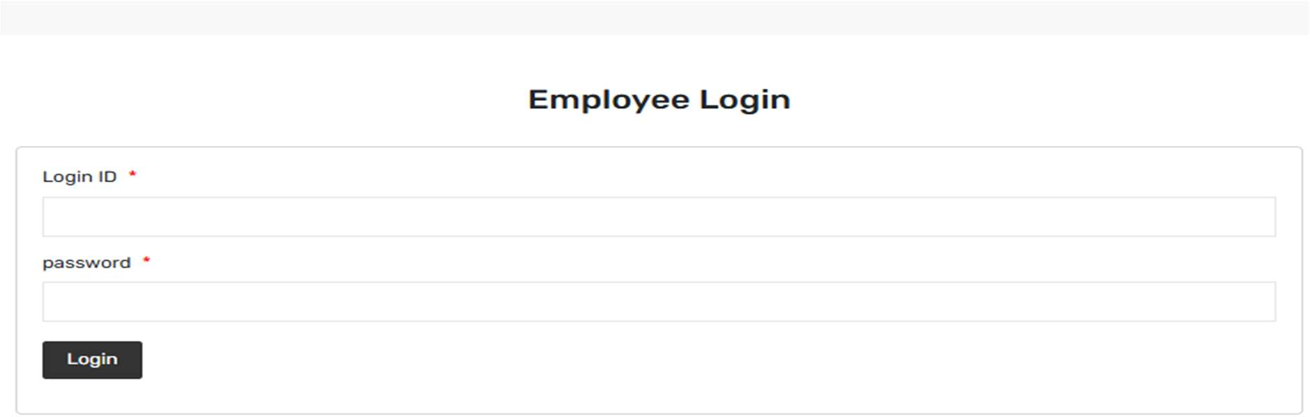

**Admin Dashboard**



**Select Category**

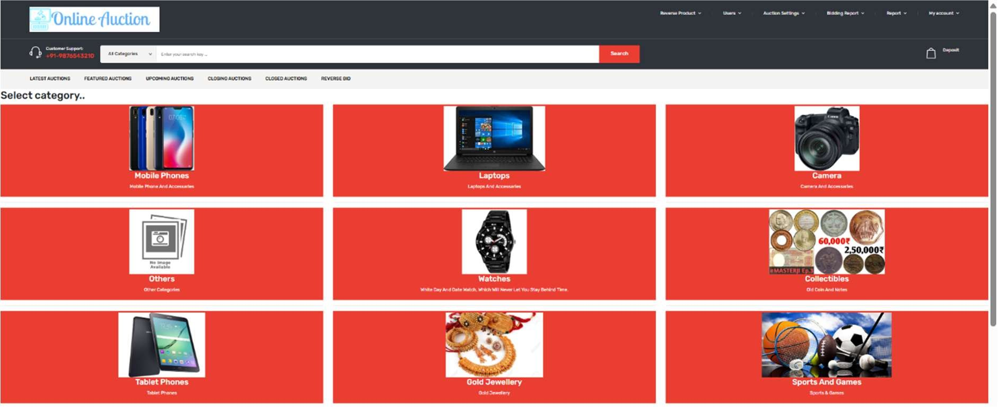

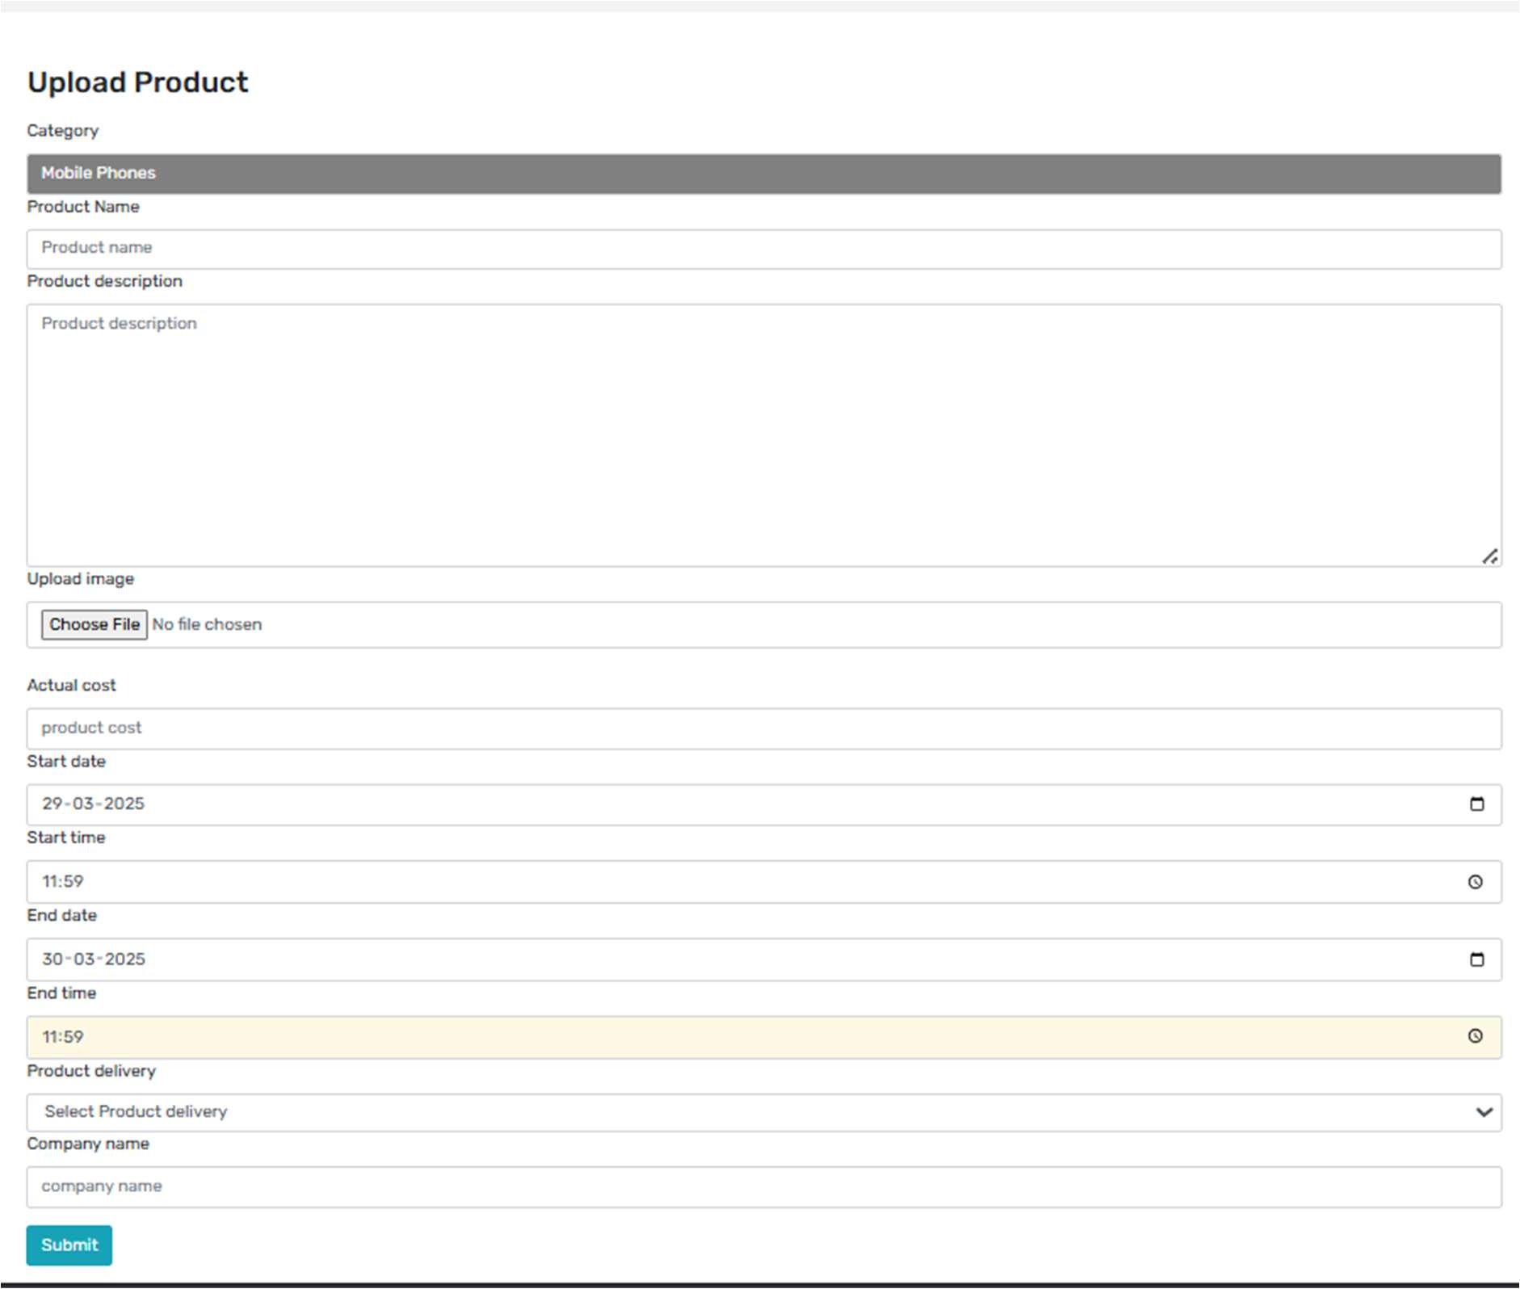**Adding a Product for the given Categories**

**Admin can easily access the customer database**

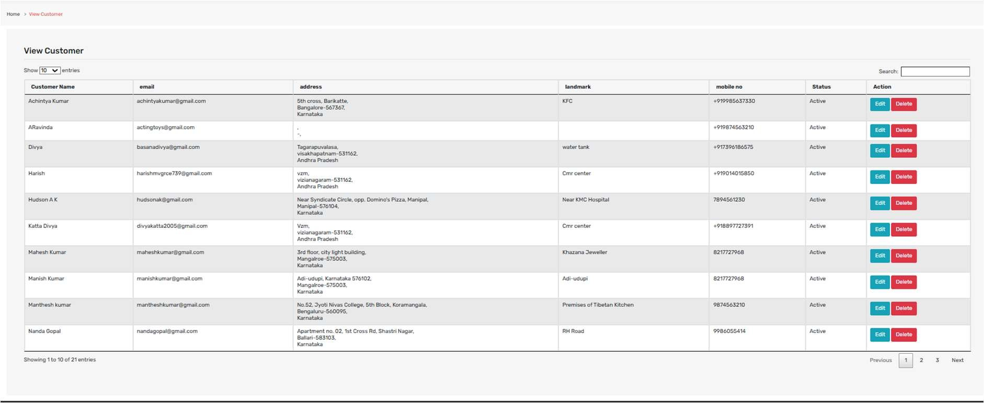

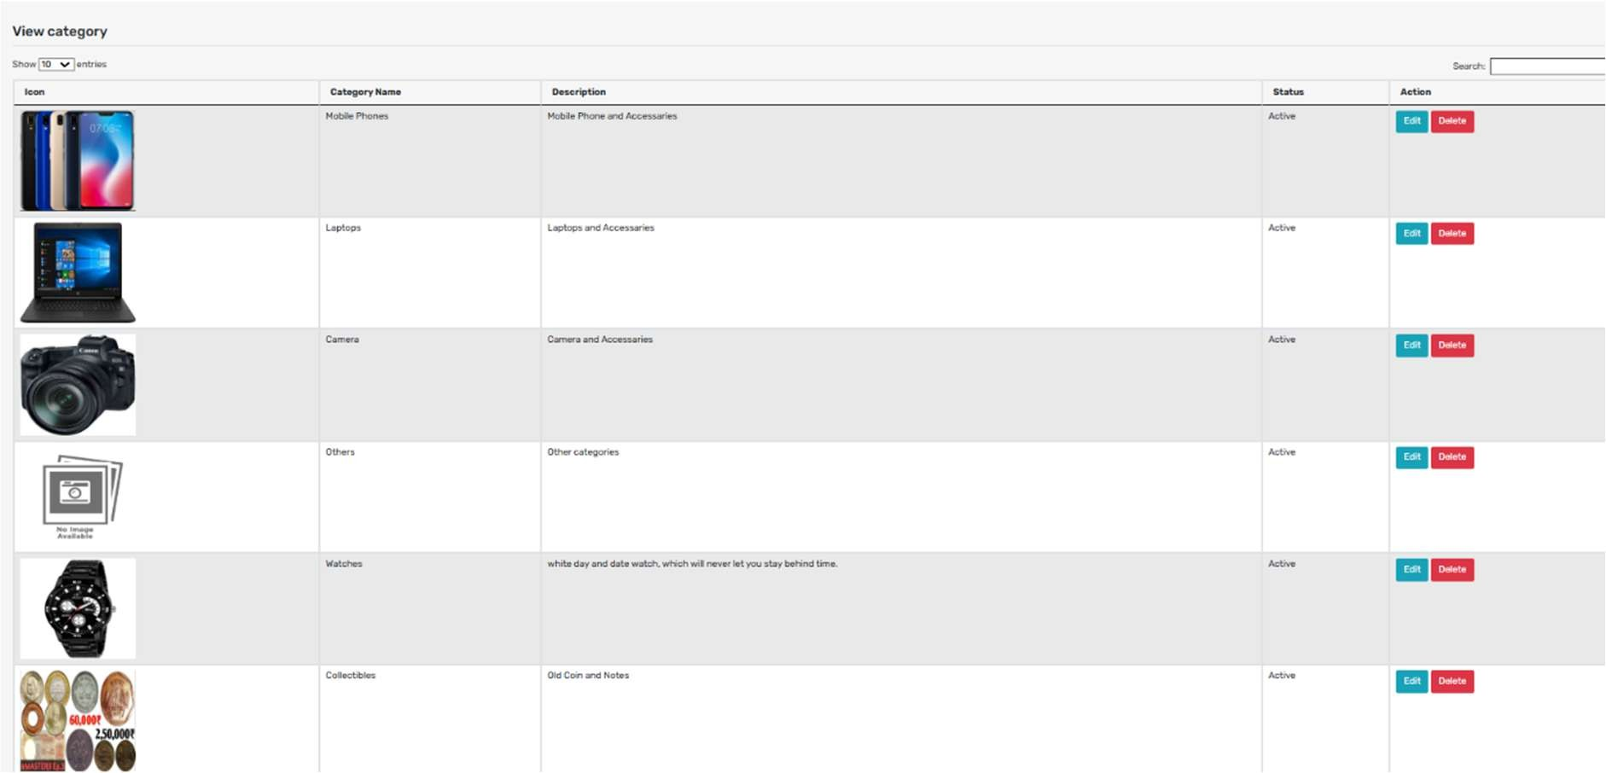**View categories**

**Adding Categories Data**

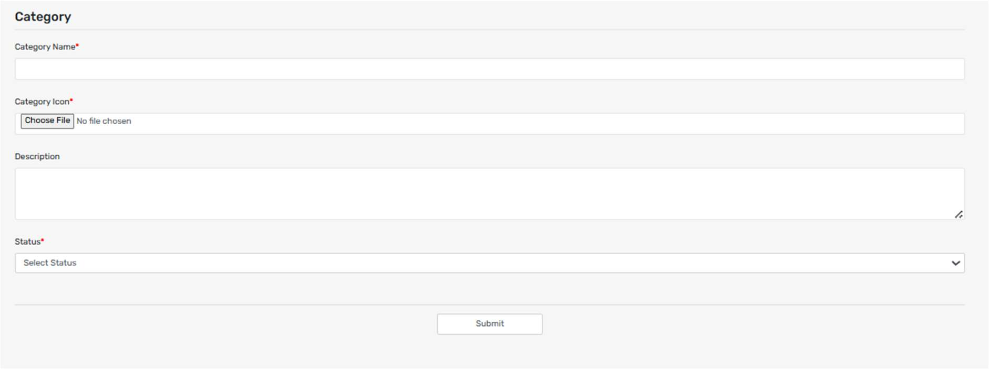

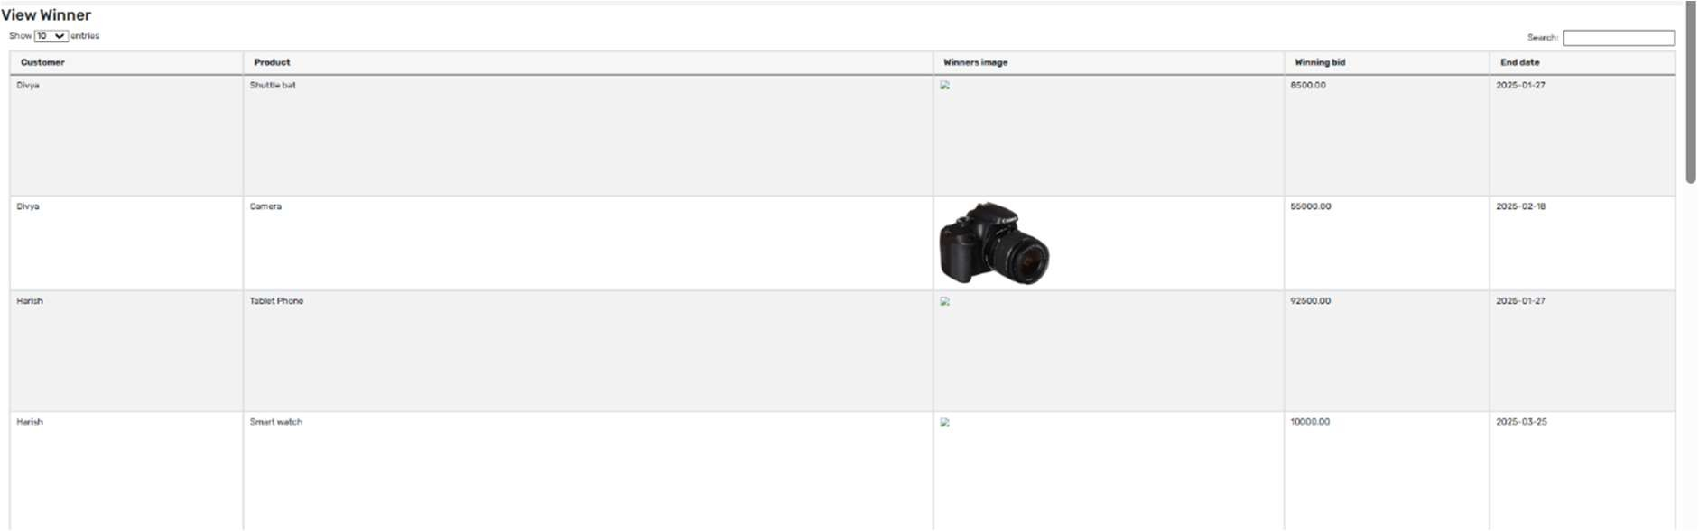**View Winner**

**Payment Report**

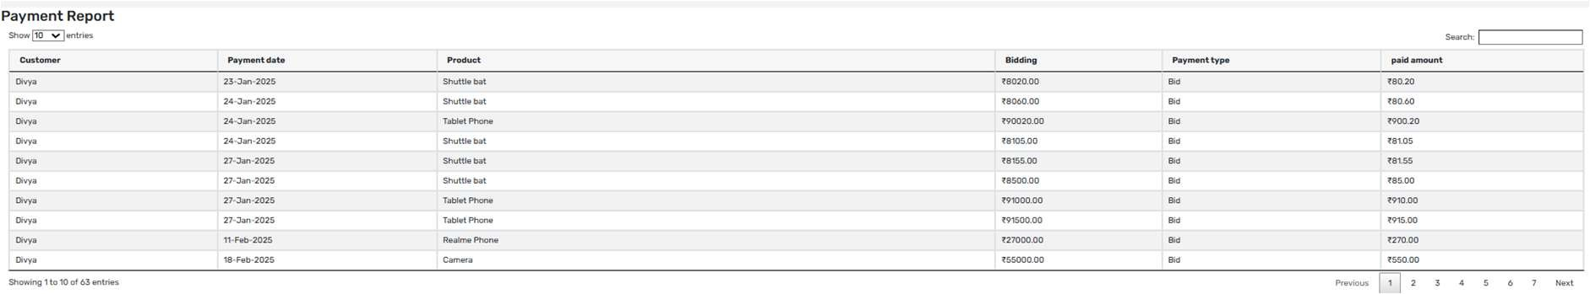

**CUSTOMER**

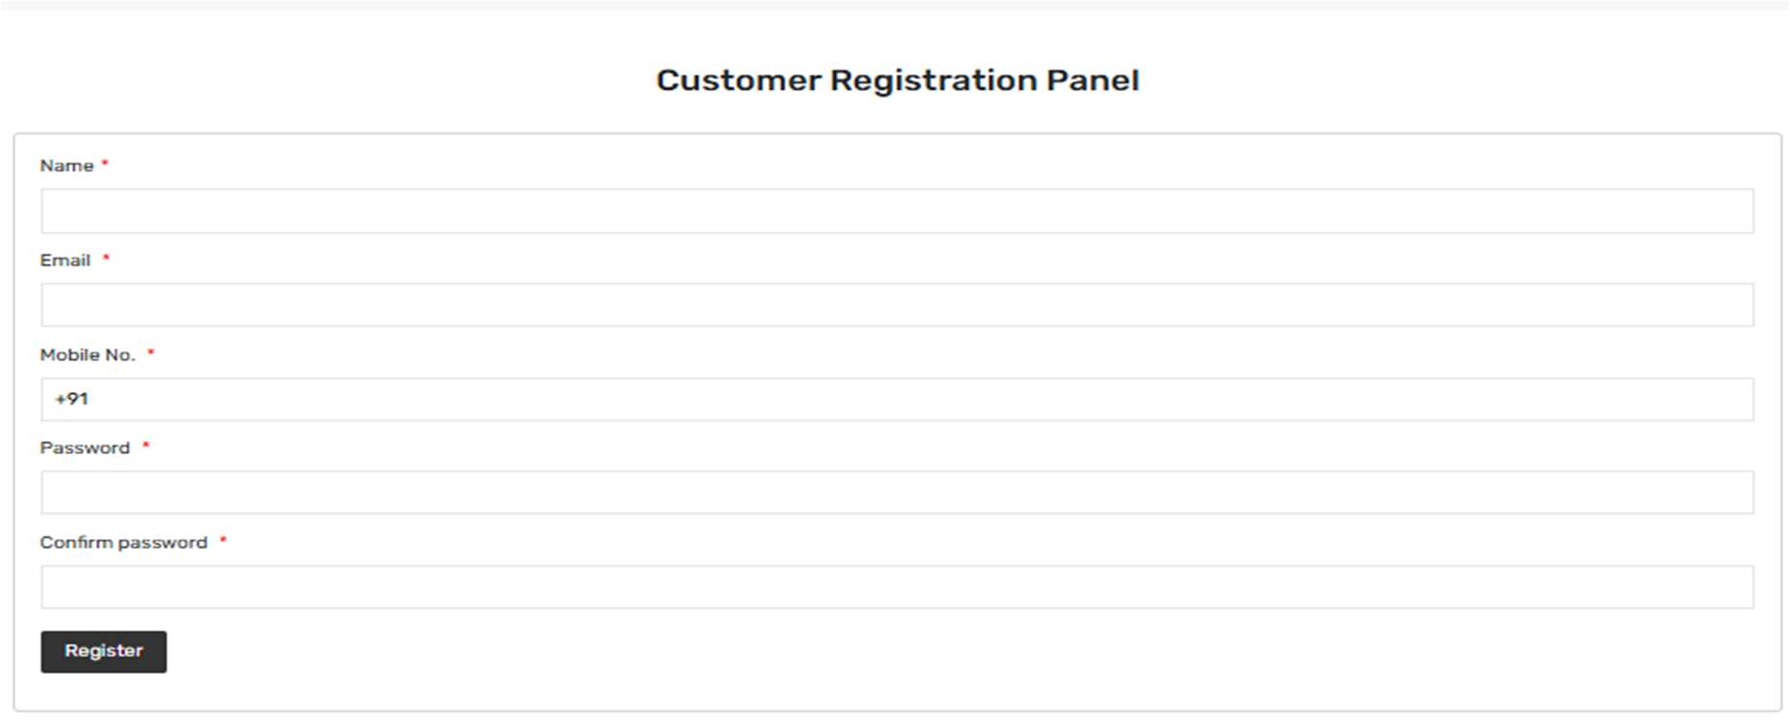

**Customer Dashboard**

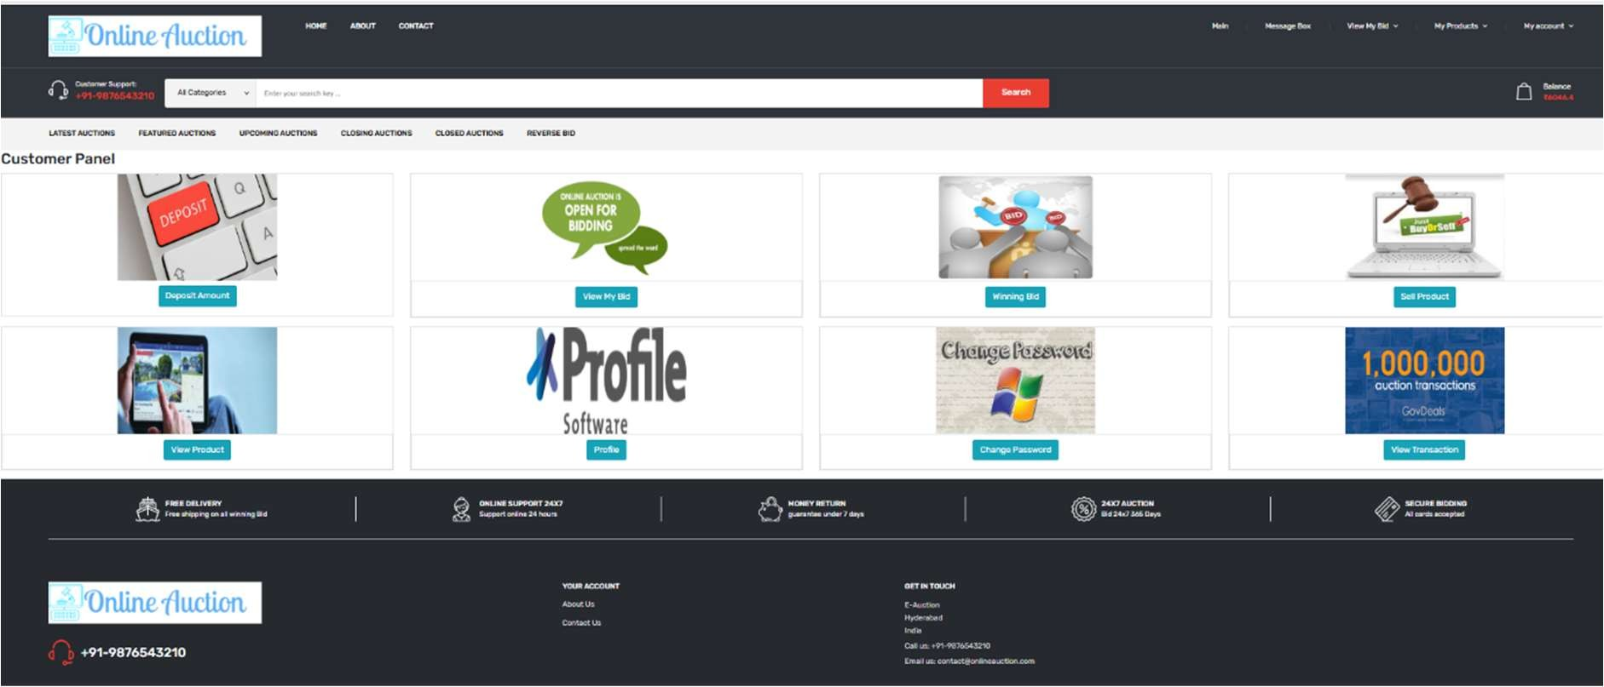

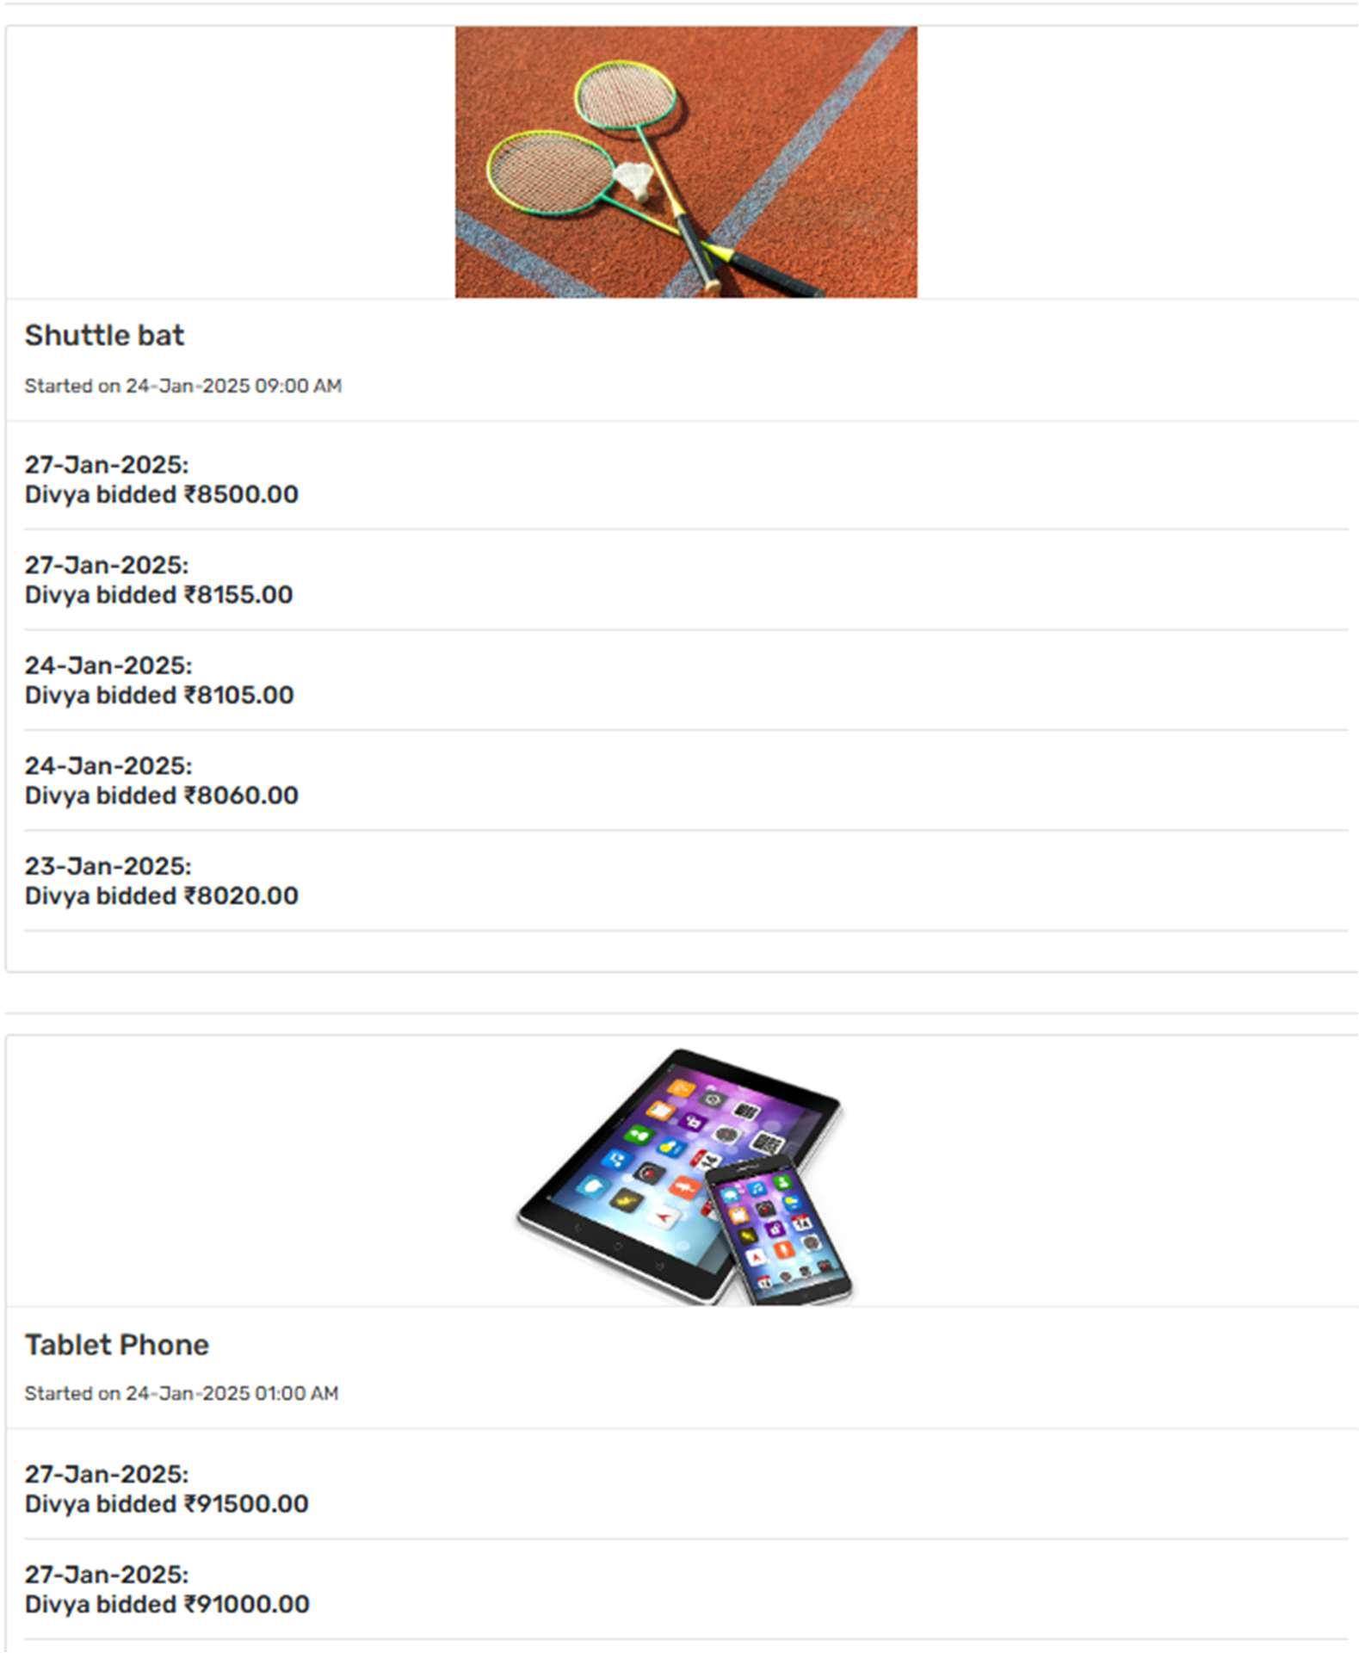**Bidding History**

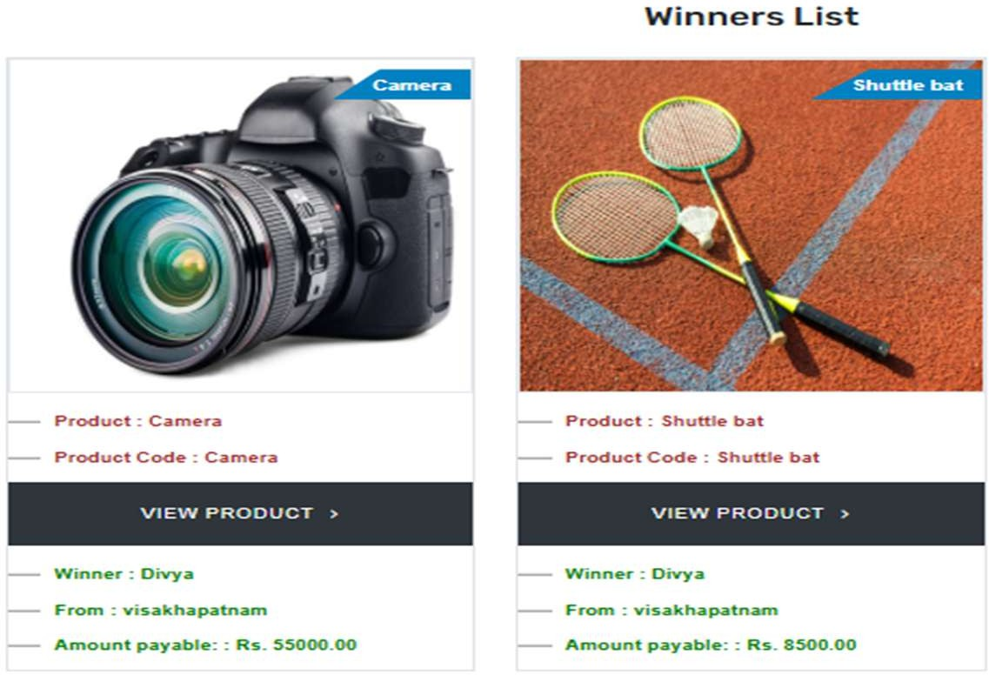

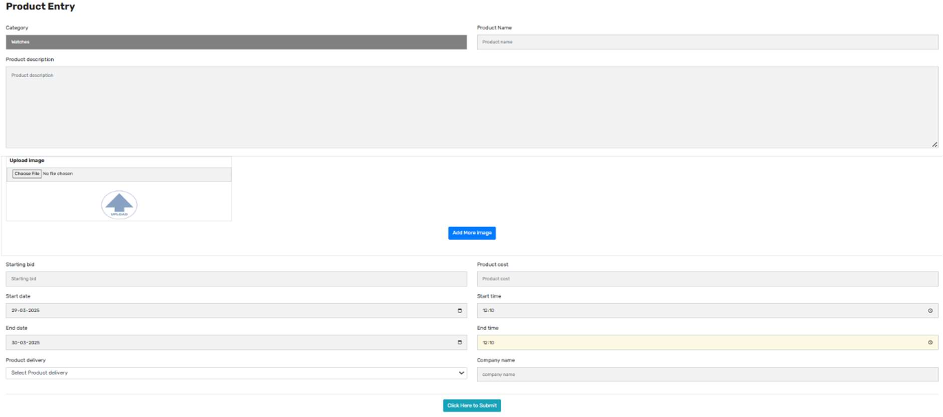

**Products added by the user:**

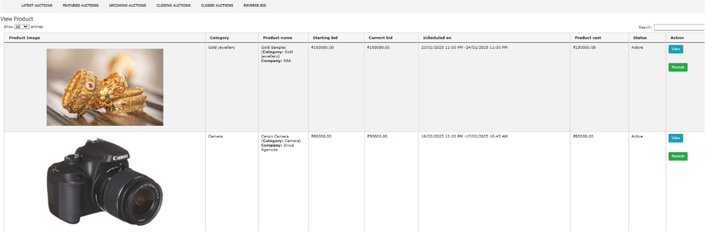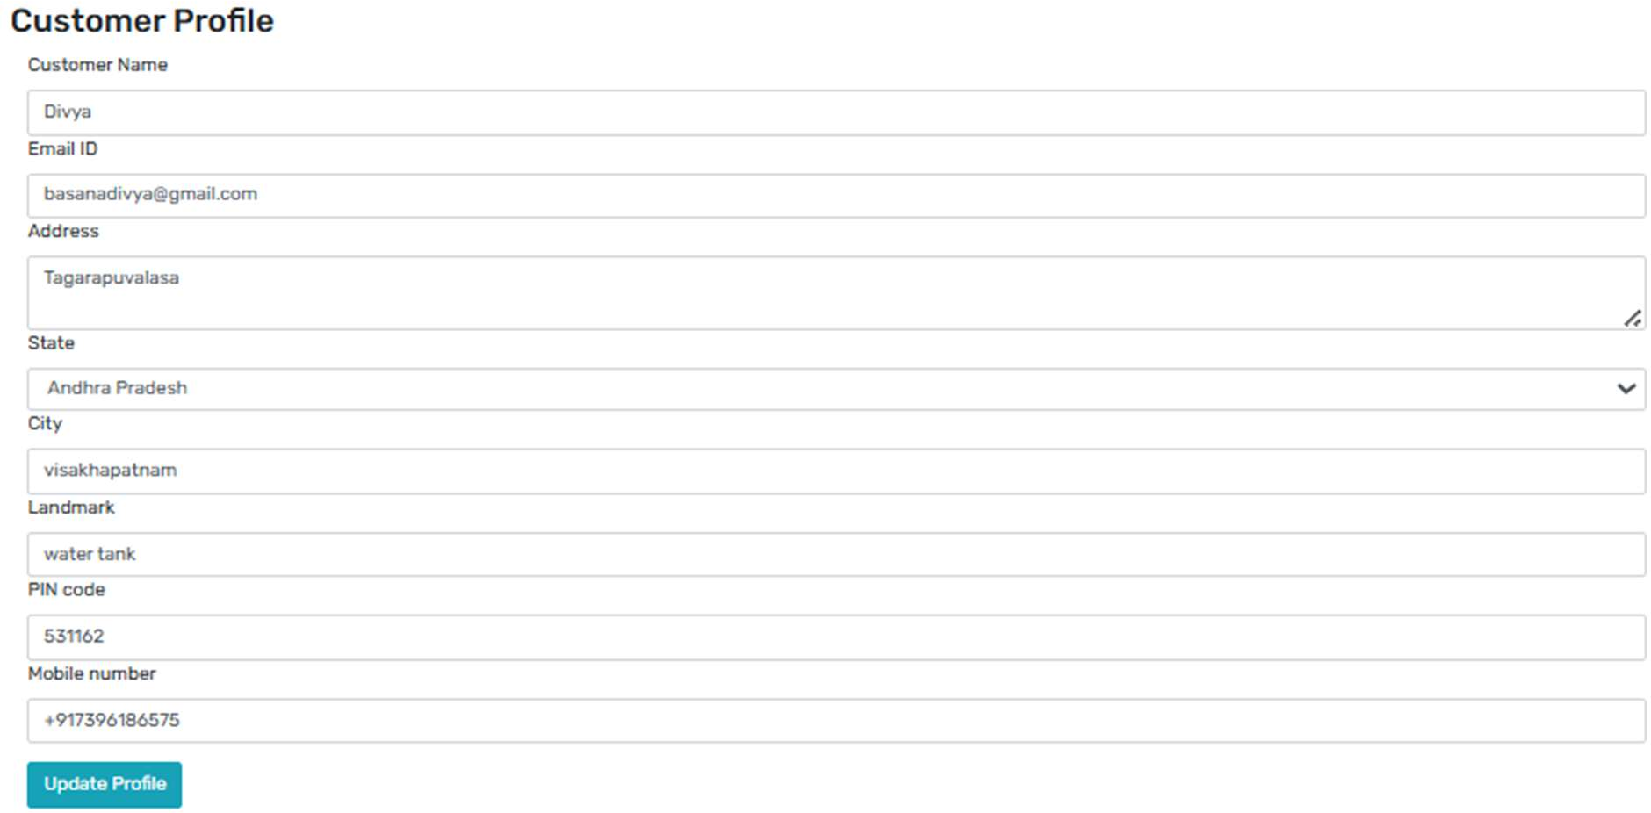

**Bidding for the product:**

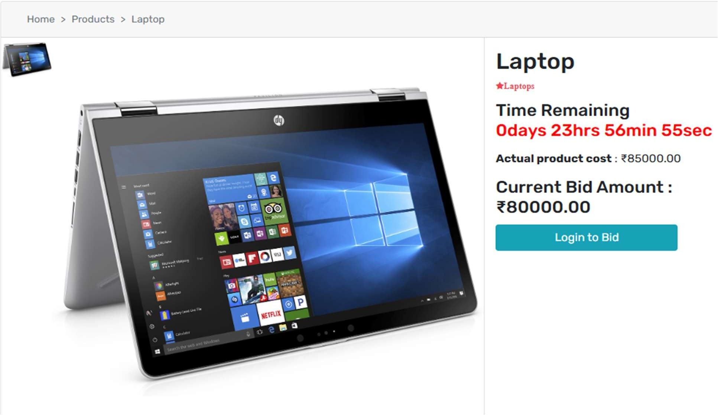

**Confirming the bid**

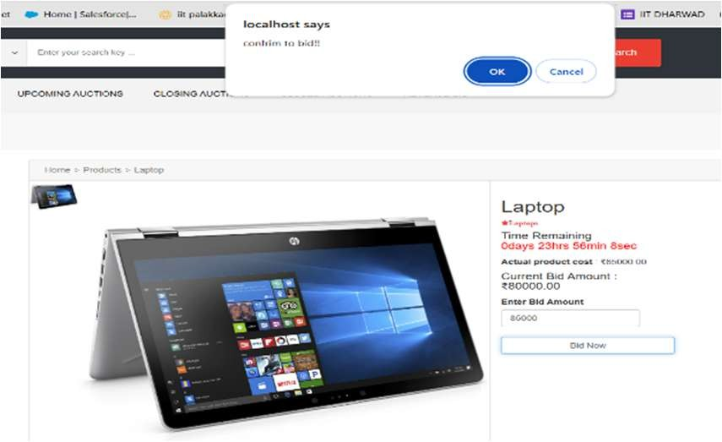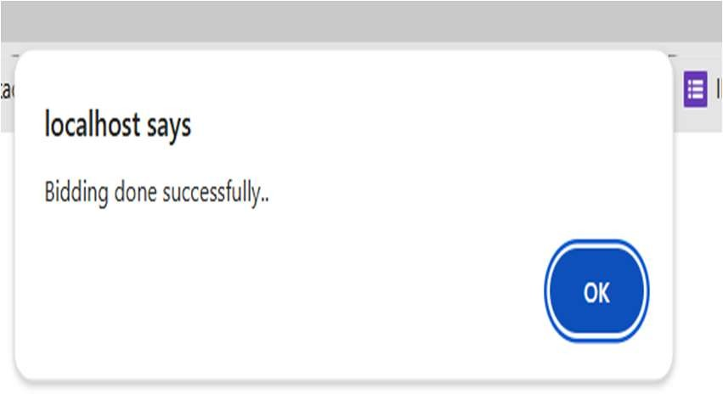

**Bidding for the Product History**

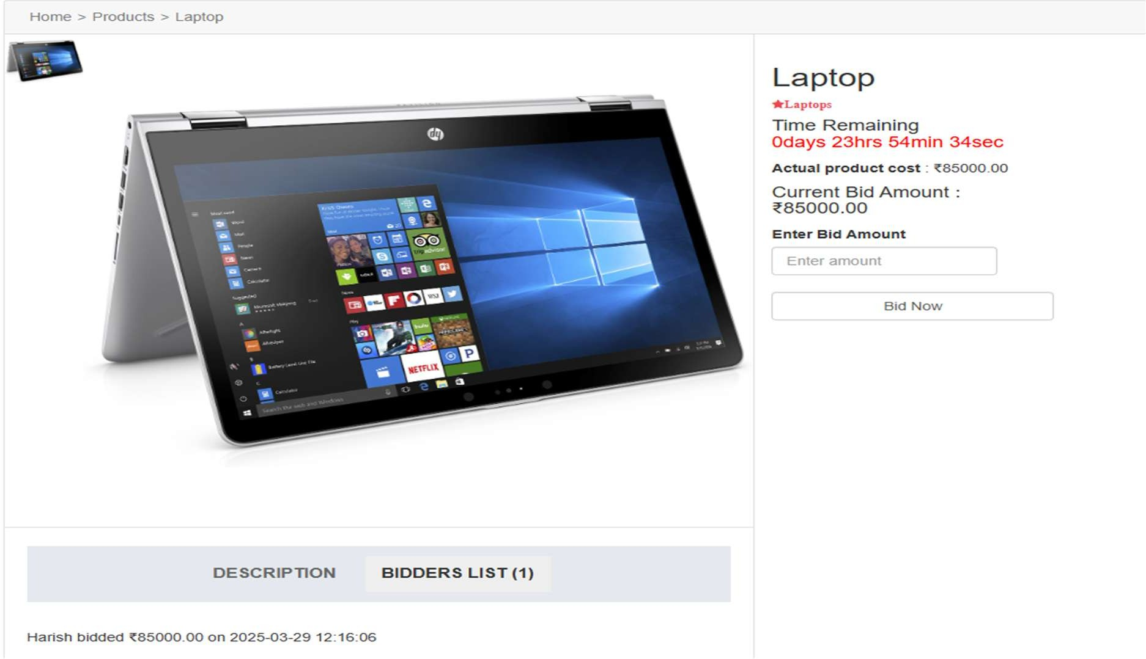

**Winning product**

